Open an account in www.studyspanish.com

Step 1. Click LOG on/off

Step 2. Click LOGIN

Step 3 . Click REGISTER. Use your first and last name.
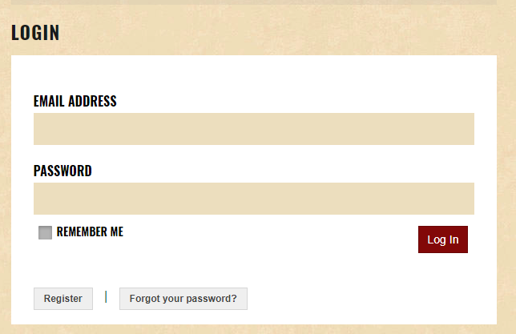

Step 4. Click on Membership Levels
Choose free student membership and register.

Step 5. Click log on/off again.
Click on MY ACCOUNT and read instructions below to add my teacher ID.
Teacher ID: lqoQ9c59
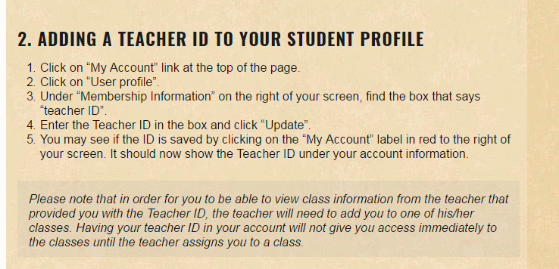
Do all the assignments listed under “my class”. They will be graded automatically, you can retake them as many times as you want.

